**Task 1**

**Clone the project from the GitHub link shared in resources to your local machine. Build the code using Maven commands.**

For building the code using Maven, command first install some plugins related to build for that go to to select **manage Jenkins >>select manage plugins** then in the available section search for **maven integration plugin**

click on **install without restart** it will install plugin how to build a job .

Click on back to dashboard then select **new item** to create a Maven job it will pop up new window enter the name of atom for job then select **Maven project** and click on Ok

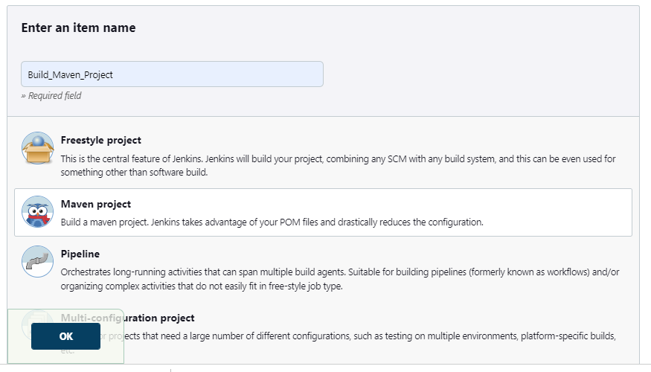

Then log in to your **GitHub** account and go to repository where your source code is available click on the **code** button that shown in green color it will pop up a window where it will show the path of GIT repository that we want to copy it provides three kinds of path status **HTTPS, SSH, GitHub CLI**

Choose **https** path click on double square near https path copy it.

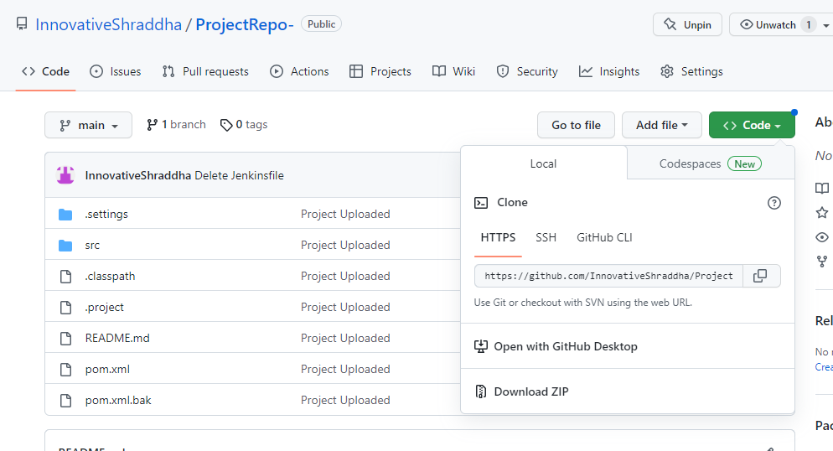

Then go to Jenkins server go to the job we were created before in that go to configure >> source code management section click on git and provide and paste the URL that we were copied in our previous step from GitHub

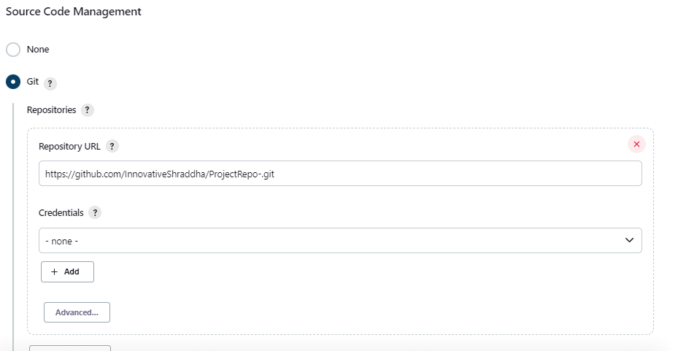

In the world section provide the Maven command as **clean install** in **Goals and Options**, Click on **save** button and build the job.

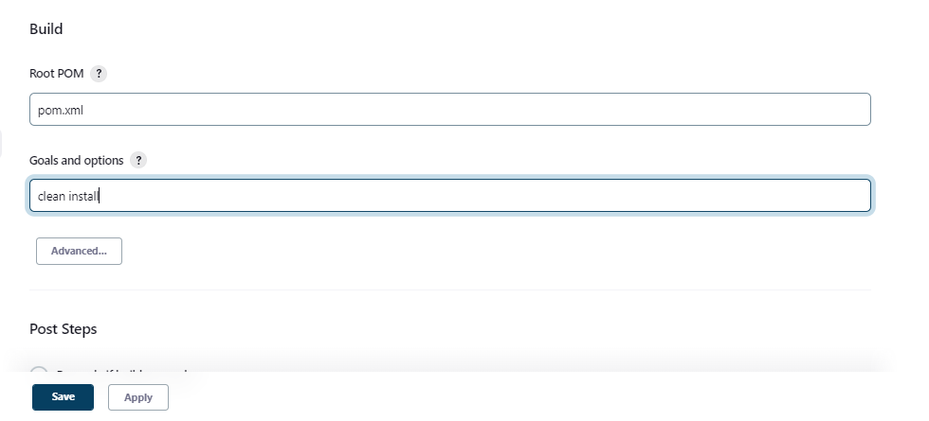

After build gets successful it will show following results in the console output as shown below screenshots.

